Practical Application – Analog PID controller
The purpose of this assignment is to analyze the schematic of a circuit, built mostly with opamps, that implements a fully analog PID controller based on the architecture shown in the following diagram.
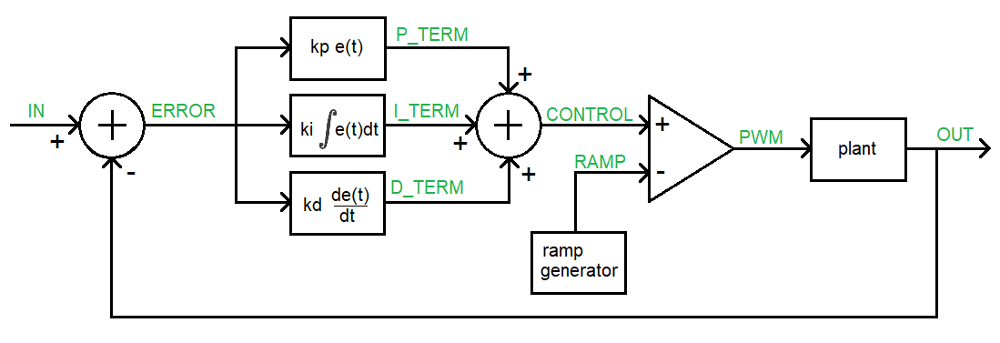
Figure 1: A PID controller subtracts the output from the input to generate an error signal. The error signal, its integral and derivative are multiplied by adjustable constants, added together, and then used to generate a PWM signal whose duty cycle is proportional to the control signal. The PWM signal is the input to the plant (thing that we want to control) which generates the observable output that is feedback into this loop.
Your task is to identify the building blocks in the schematic, analyze their behavior and relate these building blocks to the PID controller shown in Figure 1. When referencing opamps in the schematic, use the “ICxx” label, not the “TLC274P” label. When needed, assume that VCC=9V and VSS=-9V. Annoying to setup but this allows the error to be either positive or negative according to the sign of the voltage – very usefully semantically.

- The first summer junction
  - What opamp and resistors form the summer junction that outputs ERROR in Figure 1?
IC2B, R15, R16, R17, R18
  - Write an equation for the output ERROR in terms of IN and OUT.
ERROR = IN - OUT
- The proportional term, P_TERM, is formed by two opamps. ERROR is the input to the first stage and P_TERM is the output from the second stage.
  - What opamp/resistors in the form the first stage of the P_TERM in Figure 1?
IC2C, R5
  - What is the range of the gain of this circuit? Make sure to include the sign.
This is an inverting configuration so Gain = – R2/R2 [0, -∞]
  - What opamp/resistors form the second stage of the P_TERM in Figure 1?
IC2D, R8, R10
  - What is the gain of this second stage?
This is an inverting configuration so Gain = – R2/R2 = -1
  - What is the purpose of this second opamp stage?
Invert the gain from the first stage so the overall gain is positive.
  - Why didn’t I use a non-inverting opamp instead of this 2-stage approach? Hint, look at your answer for part b.
Because the gain of a non-inverting configuration is 1+R2/R1, meaning that you can only form gains which are greater or equal to 1 and perhaps you would want a gain that is less than 1.
- The integral term, I_TERM, is formed by two opamps. ERROR is the input to the first stage and I_TERM is the output from the second stage.
  - What opamp/resistors in the form the first stage of the I_TERM in Figure 1?
IC1D, R6
  - Where have you seen this circuit before?
This is the same circuit as P_TERM circuit.
  - What opamp/resistors form the second stage of the I_TERM in Figure 1?
IC2D, R9, C4
  - Write an equation for the output of the second stage, I_TERM, in terms of the input (call it ERROR) and C and R. Use C and R in your equation, not their values of uF and 10kΩ.
I_TERM = 1/RC * ∫ERROR(t)
  - Why did I use an inverting integrator circuit instead of a non-inverting integrator?
So that you could have a gain in the range [0, -∞].
- The derivative term, D_TERM, is formed by two opamps. ERROR is the input to the first stage and D_TERM is the output from the second stage.
  - What opamp/resistors in the form the first stage of the D_TERM in Figure 1?
IC1C, R7
  - Where have you seen this circuit before?
This is the same circuit as P_TERM circuit.
  - What opamp/resistors form the second stage of the D_TERM in Figure 1?
IC1B, R12, C3
  - Write an equation for the output of the second stage, D_TERM, in terms of the input (call it ERROR) and C and R. Use C and R in your equation, not their values of 1uF and 10kΩ.
D_TERM = 1/RC * dERROR(t)/dt
  - Why did I use an inverting differentiator circuit instead of a non-inverting differentiator?
So that you could have a gain in the range [0, -∞].
- The second summer junction
  - What opamp and resistors form the summer junction that outputs CONTROL in Figure 1?
IC3A, R19, R20, R21, R22, R24
  - Write an equation for the output CONTROL in terms of P_TERM, I_TERM and D_TERM.
CONTROL = (P_TERM + I_TERM + D_TERM) / 3.3
  - What value “should” the 3.3kΩ have? Why did I choose 3.3kΩ instead of this value?
The value should have been 3kΩ because you should divide by 3 because you added 3 terms.
  - Why did I use an non-inverting summer instead of the simpler inverting summer?
To make the control signal have the same sign as the inputs.
- The ramp generator is identical to the one you built in Lab 2. Using your lab results will simplify answering the questions in this section.
  - What components form the Schmitt Trigger Relaxation Oscillator (STRO)?
IC3C, (optional R31) R32, R33, R34, R35, R36, R37, D1, D2, C11
  - What is the period/frequency and duty cycle of the waveform generated by the STRO? Assume that potentiometer R35 is set to 0Ω.
Period = 7ms, Frequency = 1/7ms = 143Hz with a duty cycle of 1%
  - Does R35 effect the time high or time low of the STRO waveform?
The potentiometer R35 effects the time low of the STRO waveform.
  - Components T1, T2, R29, and R30 forms a 0.7mA current source leaving the “bottom” of T1 (it’s collector). Assume that C10 is not populated, how long does it take to charge C9 from -9V to +9V? How would you describe the shape of the voltage vs. time waveform?
Since I = CdV/dt, then dV/dt = I/C which equals 0.7mA/100nF = 7000V/sec
In order to charge the capacitor from -9V to +9V, the capacitor would have to swing through 18V. So 18V*1sec/7000V = 2.6mS Since dV/dt is a constant, the waveform will be a straight line (ramp) from -9V to +9V.
  - What is the role of Q1 in generating the RAMP waveform?
Q1 periodically clears the charge off the capacitor pair C9, C10
  - What is the role of R35 is this circuit?
Allows us to adjust the period of the reset signal to clear the charge off C9, C10.
- The comparator
  - Given RAMP (in red) and CONTROL (in blue) shown in the following timing diagrams, draw the output PWM signal using the open-loop opamp configuration shown in Figure 1.
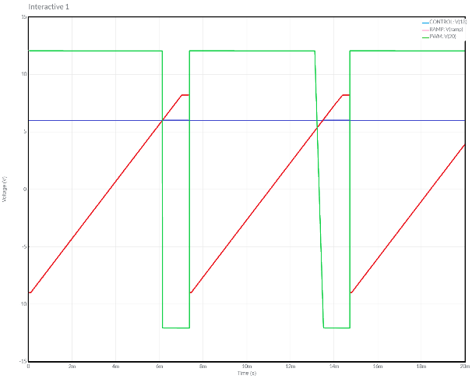 | 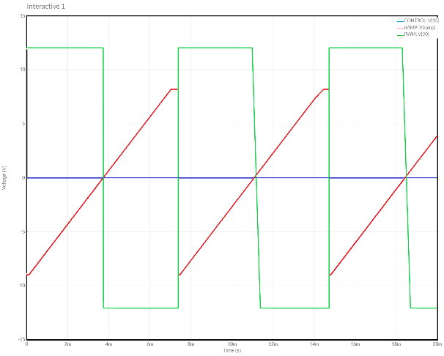 | 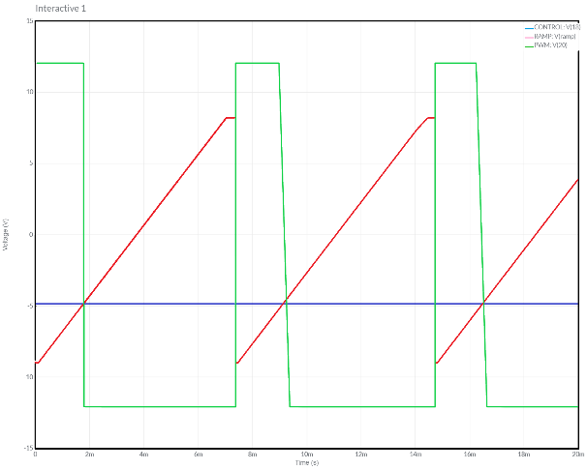

  - What is the relationship between the CONTROL signal and the duty cycle of the PWM signal? To determine this, plot the duty cycle vs control voltage and then write an equation to describe the straight-line y=mx+b style.
Duty cycle = 100/18 CONTROL + 50

- The plant, formed by the pair of opamp IC4D and IC4C in Figure 1, is a 4th order low pass filter (LPF) that converts the PWM output of the comparator into a DC signal whose voltage is proportional to the duty cycle over a -9V to +9V scale. The transfer function for IC4D is given by T1 and the transfer function for IC4C is given by T2.
$$T1\left(s\right)= \frac{66,840}{s^{2}+247s+66,840} T2\left(s\right)= \frac{297,100}{s^{2}+97s+297,100}$$
  - Use the following Mattab script to form the Bode Plot of the two stages of the low pass filter (LPF) in series.
% Make sure the control systems toolbox is installed
s = tf('s');
T1 = 66810/(s^2 + 247*s + 66810);
T2 = 297100/(s^2 + 97*s + 297100);
bode(T1*T2); waitforbuttonpress;
nyquist(T1*T2);

  - What is the attenuation of the LPF at low frequencies – express your answer in decibels.
The passband of the LPF attenuates inputs by 0dB.

  - What is the -6dB corner frequency in Hz. Remember that the Matlab plots are in radians/sec.
From the Bode plot the -6dB point is 628 rad/sec which is equal to 100Hz.

  - Using the information in the Bode plot, how does the LPF convert the PWM waveform into a DC value?
The intent of the LPF is to convert the PWM waveform into a DC value which is the average value of the PWM waveform. Mathematically you can see this by representing the PWM waveform by its Fourier Series. Consider this series to have two types of components, DC and not AC.
The DC component of the Fourier Series is the average value of the PWM waveform. Since the frequency of DC is 0Hz the low pass filter passes it through with 0dB of attenuation (see the answer to part b). Since 0dB of attenuation is “no change”, the DC value passes unchanged through the filter.
The AC components of the PWM waveform have frequencies which are integer multiples of the fundamental frequency, which is the frequency of the PWM waveform, 143Hz (see the answer to question 6b). These frequencies are higher than the corner frequency, 100Hz, which means that their attenuation is -80dB/decade. This is a substantial attenuation which will effectively block these harmonic frequencies from appearing at the output.

  - What role is opamp IC4B and R38 serving?
It allows an adjustable gain in the range [0, -∞].
  - I put IC4A into the circuit to buffer the plant from the other circuit elements. What is the gain of this stage? What is the effect of this stage on the gain of the previous stage.
The opamp is in an inverting configuration and its gain is -1. This stage inverts the gain of the previous stage, so the overall gain of the plant is positive.

  - Use the information in the Nyquist plot, is the closed loop feedback system with gain = 1 (integral and derivative gains = 0) stable?
Leaning heavily on EENG 307 concepts for this one. Since the (open-loop) transfer function T1(s)*T2(s) does not have any unstable poles, any encirclements of -1+j0 that the Nyquist plot makes means that the closed loop feedback system with gain = 1 will be unstable (source). Looking at the plot provided by Matlab in Figure 2(left) we see two clockwise encirclements of -1+j0 (shown as the red “+” in the plot). This means that the closed loop feedback system with gain = 1 is unstable.
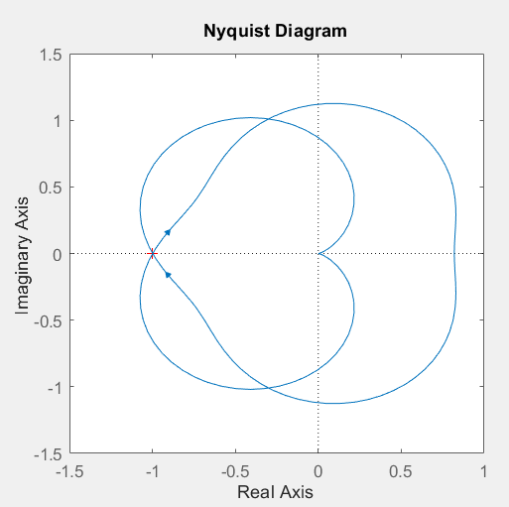
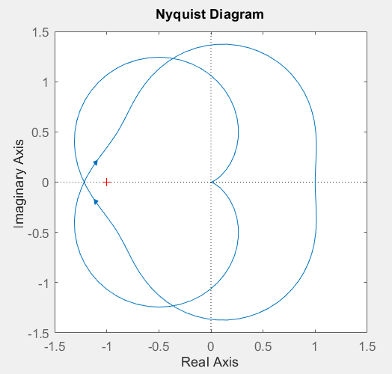
Figure 2: (left) Nyquist plot of T1*T2 shows two encirclements of -1+j0 implying that the closed loop feedback system formed with T1*T2 as its plant is unstable with the proportional gain is set to 1. (right) The Nyquist plot of 0.82*T1*T2 shows that the -1.7dB gain margin in the left figure exactly predicts when the lobes of the Nyquist begin to encircle -1+j0.

Going further, how could we make the closed-loop feedback system with gain = 1 stable? Using the “margin(T1*T2)” command in Matlab we get that the gain margin is -1.7dB. Using the decibels equation, we deduce that 20log(gain) = -1.7dB yields gain = 0.82. This means that in order to make the closed loop system stable, we need to set the gain of the IC4B and R38 to 0.82. Well actually -0.82, but the following inverter formed by IC4a, R27 and R28 multiplies the gain by -1, so the gain of IC4B is implicitly positive. When we set the gain to 0.82 the Nyquist plot is on the verge of encircling -1+j0, see Figure 2 (right). Smaller gains will retract the Nyquist plot further making the closed loop feedback system more stable.

This page was intentionally left blank in order to keep the page count correct.

Delete this page in Adobe and replace with PID controller schematic

